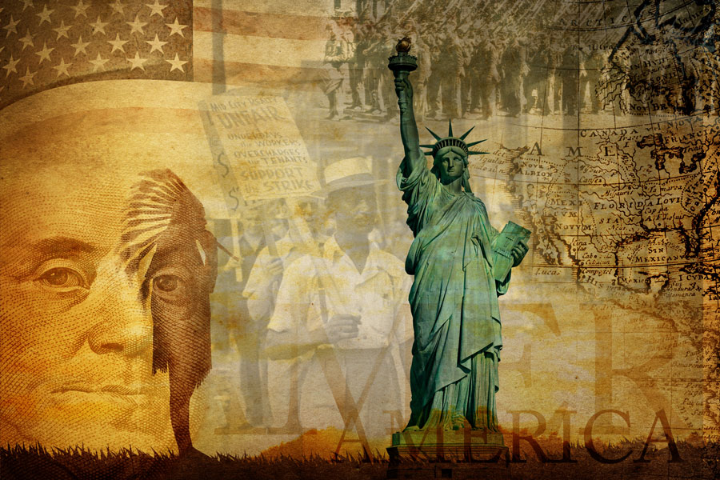

The Executive Branch

American Government Unit Companion
Directions
- Complete Prepare and Strategies for Success sections before you begin a unit.
- Complete Summaries and Reflect and Review sections before you take the unit assessment.
- For more details about each section, return to the course overview unit.

Prepare
Throughout the Executive Branch unit, you will explore the following Essential Questions.

Essential Questions
- What qualities must a president have to be an effective leader?
- How much power should the executive branch have?
- How should the president meet the needs of the American people?
In Lessons 1–4, you will learn about the following topics:
- the different roles and duties of the president
- the official and unofficial qualifications of the job of president of the U.S.
- the office of the vice president
- the role of political parties and the electoral college in presidential elections

At the end of Lesson 4, you will take a cumulative quiz.
In Lessons 5–7, you will learn about the following topics:
- the powers the Constitution gives the executive branch
- how the powers of the executive check and balance the other branches of government
- the federal bureaucracy, or how the executive branch makes and manages public policy
- the scope, or range, of executive powers
At the end of Lesson 7, you will take a cumulative quiz.
In Lessons 8–12, you will learn about the following topics:
- the government agencies and departments that enforce laws and policies
- the executive branch’s role in national security and defense
- the different approaches the executive branch takes to carry out its relationships with other nations
- how the executive branch can best support and defend human rights around the world

At the end of Lesson 12, you will take a cumulative quiz.
In Lesson 13, you will write a report advising the president.
In Lesson 15, you will take a cumulative test.

Strategies for Success

Support Ideas with Evidence
From convincing your friend that the latest Star Wars movie is the best film of all time or persuading your parents to extend your curfew, it’s likely you have used the skill of supporting ideas with evidence.
Throughout The Executive Branch unit, you will explore the different people and organizations that help the president carry out the powers of the office. You will learn that although the president has a lot of power, the executive branch must work with Congress and the judicial branch to carry out their work. In order to accomplish this, the president must support or back up ideas with evidence.
Without supporting evidence, words are just statements of opinion. When you use evidence, these words can become statements of fact.
President Obama in his State of the Union address in 2015, proposed a plan that would make community college free for all students who keep a minimum grade point average. In his proposal titled America’s College Promise, he begins by stating the necessity of a college degree and how critical this is at the present, especially for low income students. Read the paragraph below and to find examples of evidence he uses to support his plan.
Earning a post-secondary degree or credential is no longer just a pathway to opportunity for a talented few; rather, it is a prerequisite for the growing jobs of the new economy. Over this decade, employment in jobs requiring education beyond a high school diploma will grow more rapidly than employment in jobs that do not; of the 30 fastest growing occupations, more than half require postsecondary education. With the average earnings of college graduates at a level that is twice as high as that of workers with only a high school diploma, higher education is now the clearest pathway into the middle class.
What evidence did he cite to back up the idea that a college degree is essential?
- More jobs require college degrees than not; of the 30 fastest-growing occupations, more than half require postsecondary education.
- The average earnings of college graduates is double that of workers with only a high school diploma.
Try another example. Read the following paragraph and find the evidence to back up his idea that community college tuition should be free.
In higher education, the U.S. has been outpaced internationally. In 1990, the U.S. ranked first in the world in four-year degree attainment among 25–34 year olds; today, the U.S. ranks 12th. We also suffer from a college attainment gap, as high school graduates from the wealthiest families in our nation are almost certain to continue on to higher education, while just over half of our high school graduates in the poorest quarter of families attend college. And while more than half of college students graduate within six years, the completion rate for low-income students is around 25 percent.
- The U.S. once led the world in the number of college graduates; now ranks it ranks 12th.
- The U.S. suffers from college attainment gap, where just over half of high school graduates in the poorest 25% of the population attend college.
- Only 25% of low- income students graduate college within 6 years.

In Lesson 5, you will learn more about the president’s powers in recommending legislation.

As you work through the unit, you will have multiple opportunities to practice this skill. Remember to give evidence each time you complete a short answer question and especially when you work on your portfolio assignment, A Memo to the President.

Summaries
You may read summaries of the Magruder’s American Government textbook pages assigned in each lesson. Decide whether you want to read them before, during, or after a lesson.
- Read before a lesson to preview the most important information ahead of time, including people, places, and events.
- Read during or after a lesson to review Magruder’s American Government pages without rereading every word.
Access the American Government Summaries through the Web Links resource by selecting the backpack icon. Read the corresponding summary with the lesson.
- Lesson 1: The Executive Branch – An Overview
- Lesson 2: The American Presidency
- Lesson 3: Choosing a Side: The Political Machine
- Lesson 4: Choosing a Leader – The Electoral College
- Lesson 5: Executive Powers
- Lesson 6: The Federal Bureaucracy
- Lesson 7: The Executive Office of the President
- Lesson 8: Executive Departments
- Lesson 9: Independent Agencies
- Lesson 10: American Foreign Policy
- Lesson 11: National Security and Defense
- Lesson 12: Diplomacy and the State Department

Reflect and Review
Before the unit assessment, use the checklist to reflect on what you have learned throughout the Executive Branch unit. This will help determine what content to review to prepare for the multiple question types on the assessment.
- Read each of the statements.
- If you agree with the statement, check the box.
- Revisit statements that you did not check. Return to the lesson resources to review the content. Study the key words using the Glossary.

Statements
[] | Statement |  | Key Words |  |  | Resources
☐ | I can explain the role and principles of bureaucracy within the executive branch and identify examples of the following:  - line agencies  - independent agencies  - independent regulatory agencies  - government corporations |  | - bureaucracy  - line agencies  - hierarchy  - independent agencies  - independent regulatory commissions |  |  | - Lesson 6: Flipped Video: “Federal Bureaucracy”  - Lesson 6: Magruder’s American Government: The Executive Branch at Work > The Federal Bureaucracy> Staff and Line Agencies  - Lesson 9: Flipped Video: “Independent Agencies”  - Lesson 9 Magruder’s American Government: The Executive Branch at Work > The Independent Agencies > The Independent Executive Agencies and Independent Regulatory Commissions
☐ | I can explain the role and responsibilities of the vice president. |  | - presidential succession |  |  | - Lesson 2: Interactive Chart “Presidential Succession”  - Lesson 2: Magruder’s American Government: The Executive Branch – The Presidency and Vice Presidency > The Vice President and the First Lady > The Structure and Function of the Vice Presidency  - Lesson 2: Flipped Video “Supporting Roles”  - Lesson 2: Interactive Gallery “Four Vice Presidents”
☐ | I can describe and explain the president’s judicial and legislative powers. |  | - amnesty  - clemency  - pardon  - commutation  - reprieve  - veto |  |  | - Lesson 5: Magruder’s American Government: The Executive Branch – The Presidency and Vice Presidency > The President’s Domestic Powers > The Powers of Clemency  - Unit 3, Lesson 11:  Magruder’s American Government: The Legislative Branch > Congress at Work – Making Law > The President Acts on a Bill
☐ | I can explain the different roles and duties of the president. |  | - chief administrator  - chief economist  - chief executive  - chief citizen  - chief diplomat  - chief legislator  - chief of party  - chief of state  - commander in chief  - bureaucracy |  |  | - Lesson 1: Magruder’s American Government: The Executive Branch: The Presidency and Vice Presidency > The Presidency- An Overview > The President’s Many Roles  - Lesson 6: Magruder’s American Government: The Executive Branch at Work > The Federal Bureaucracy> Executive Branch Bureaucracy
☐ | I can explain the executive branch’s powers and role in foreign policy including the following:  - Secretary of State  - Department of Homeland Security |  | - foreign policy  - treaty  - commander in chief  - recognition  - executive agreement |  |  | - Lesson 5: Magruder’s American Government: The Executive Branch: The Presidency and Vice Presidency > The President’s Foreign Affairs Powers  - Lesson 11: Magruder’s American Government: The Executive Branch at Work > National Security > Department of Homeland Security  - Lesson 12: Magruder’s American Government: The Executive Branch at Work > Diplomacy > America’s Representatives to the World
[] |  | Statement |  | Key Words | Resources
☐ |  | I can explain the role of the Electoral College and its flaws in electing a president. |  | - Electoral College  - popular vote | - Lesson 4: Magruder’s American Government: Elections > Electing the President > Flaws in the Electoral College

