State and Local Governments

American Government Unit Companion
Directions
- Complete Prepare and Strategies for Success sections before you begin a unit.
- Complete Summaries and Reflect and Review sections before you take the unit assessment.
- For more details about each section, return to the course overview unit.

Prepare
Throughout the State and Local Governments unit, you will explore the following Essential Questions.

Essential Questions
- What are the roles and responsibilities of the states within the federal system of government?
- How do states and localities meet the needs of the people? What challenges do they face?
In Lessons 1–4, you will learn about the following topics:
- balancing state and federal power
- elements of state constitutions
- lawmaking at the state level

At the end of Lesson 4, you will take a cumulative quiz.
In Lessons 5–7, you will learn about the following topics:
- the role and responsibilities of Governors and other Executive officers
- judicial power at the state level
- organization of the state court system
At the end of Lesson 7, you will take a cumulative quiz.
In Lessons 8–10, you will learn about the following topics:
- forms of local governments
- how state and local governments provide to meet the needs of their citizens
- education and entitlement spending at the state and local levels

In Lesson 10, you will participate in a discussion whether states should increase welfare funding.

In Lessons 11–14, you will learn about the following topics:
- the state’s responsibility in providing law enforcement and roadway safety
- state budgets, spending and the principles of taxation
In Lesson 14, you will complete a portfolio assignment where you create an action plan for your local government.
After reviewing for the unit in Lesson 15, you will take a cumulative test in Lesson 16.

Strategies for Success

Reading and Analyzing Graphs
Whether in your math class or on the side of cereal box, you have probably come across tables, charts, and graphs before. Information that is shown in these ways helps you visualize data and makes the information easier to understand. If you can read and analyze tables, charts, and graphs, you can find out all sorts of information to help you make important decisions in your life.
There are several different types of charts and graphs. Closely examine the four most common types: bar graphs, line graphs, pie charts, and hierarchical charts.
Bar Graphs
Bar graphs typically show the amount or frequency of something.
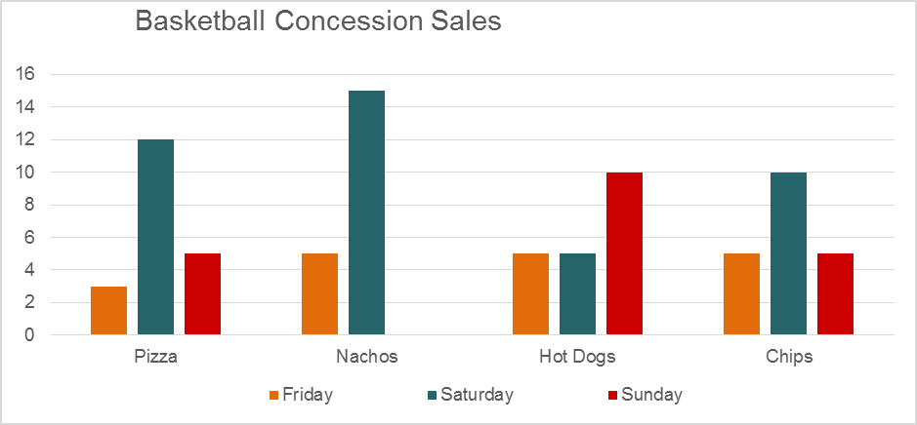
Examine the bar graph. First, identify the title of the graph. In this graph, the title is located at the top: Basketball Concession Sales. Next, look for a key or legend to help you decode what the colored bars represent. At the bottom of the graph, there are little colored squares and next to each of them, specific days of the week are listed. That information tells you that the orange bars indicate Friday sales at the concession stand, the blue bars show the sales made on Saturday, and the red bars refer to Sunday sales. Scan the text and data on the y-axis and on the x-axis to find out what kind of information is being presented. The y-axis is the vertical line going up and down and the x-axis is the horizontal line going across. On the left hand side, you can see that number of snacks sold can be found along the y-axis. Notice how the the numbers increase as you go up the line. The type of snacks sold—pizza, nachos, hot dogs, and chips—are listed in clusters along the bottom or x-axis. Now summarize what the graph is intending to show. So, the heights of the bars on this graph must show the number of each type of snack sold on each day, and therefore the graph shows the amount of snacks sold at the basketball game concession stand on Friday, Saturday, and Sunday.
Line Graphs
Line graphs show you how numbers have changed over time. They are commonly used to show trends or patterns. Examine the following graph and identify its title, key, and legend. Use that information to scan the text and data on the y-axis and x-axis before summarizing what the graph is presenting.
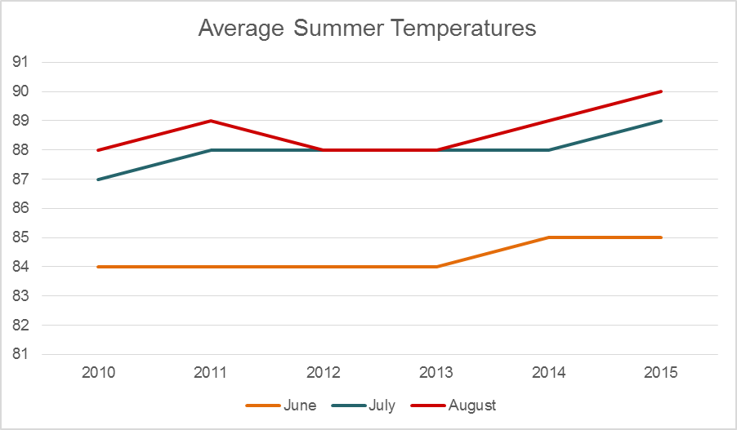
This line graph shows average summer temperatures over a 5-year period from 2010–2015. Now that you know what the graph is about, analyze this graph. First, look for any patterns or trends in the information. Start with the x-axis along the bottom of the graph and focus on one year at a time. To find out the average temperature in June in 2010, first look for the year the 2010, and then find the blue line above it. To identify the average temperature in June, find where that orange line lands on the y-axis or left hand side. In this example, the average temperature in June was 84 degrees. Do this again for July and August. Now look at the next year, 2011, and scan the information. After you have finished looking at every year on the graph, can you tell if there are any patterns, repeated events, or trends? One pattern is that the temperatures are hotter in June on average than in August, no matter the year. Another pattern is that temperatures have risen in each month in the last years.
Pie Charts
Pie charts are circles cut up into segments, like pieces of a pie. These charts show you how a whole is divided into separate parts. Review the pie chart below and summarize what information is being presented.
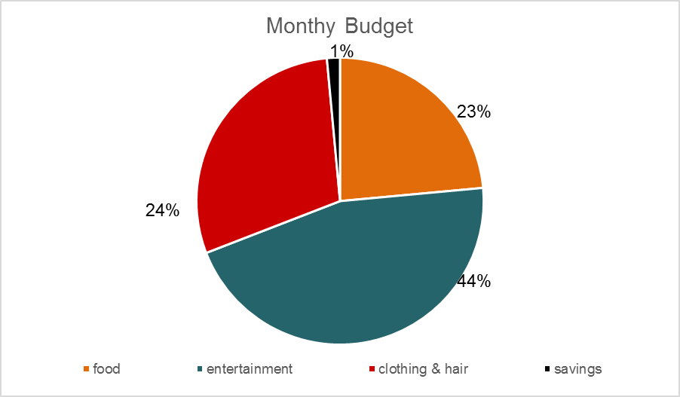
The pie chart shows the percentage of money that was spent, during a month, in four separate categories. On which category did most of the money go toward? Which category did the least amount of money get spent? According to this chart, nearly half of the money was spent on entertainment, followed by clothing and hair, food, and lastly, savings. After reading and analyzing the chart or graph, you can now use the data to better understand an issue and make choices. For instance, you may decide that you need to put aside more money in savings each month. Using this pie chart, you can identify the categories where you spend more money, such as entertainment, and then spend 10% less there and put that money toward savings.
Hierarchical Charts
Hierarchical charts show the structure of an organization and the relationships in the organization. These charts are helpful in understanding authority, responsibility or the chain of command of a business, team, or group. Following is a chart that shows the hierarchy of staff members at a restaurant.
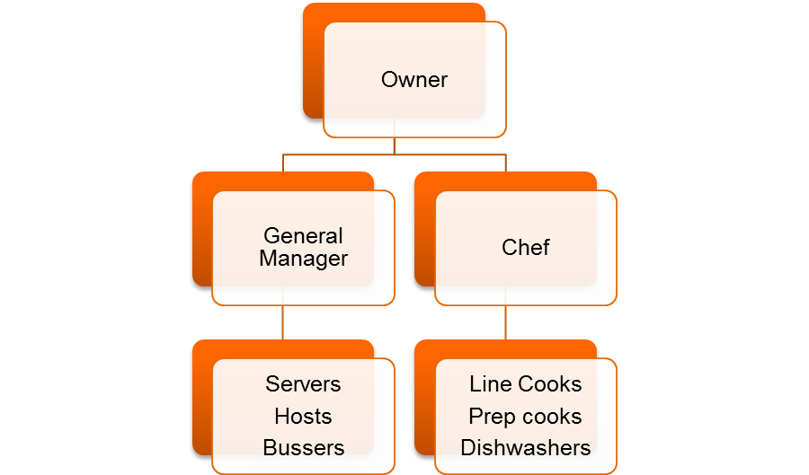
At the top is the the owner of the restaurant, who is the person with the most authority at the restaurant, or first-in-command. The General Manager and chef are below the owner. Under the General Manager are the servers, hosts and bussers. Below the chef, are the line cooks, prep cooks, and dishwashers. Imagine you were working as a busser at the restaurant. Who would you first speak to if you needed to change your work schedule? Most likely, you would speak to the General Manager and not the owner of the restaurant or chef. How could hierarchical charts help you? If you ever had a problem with an organization, company, product, or service you could use a hierarchical chart to identify the department or people who help you solve the problem.
You will have many opportunities to read and analyze charts and graphs throughout the unit. Remember to review this material before creating your own chart in your portfolio assignment.

Summaries
You may read summaries of the Magruder’s American Government textbook pages assigned in each lesson. Decide whether you want to read them before, during, or after a lesson.
- Read before a lesson to preview the most important information ahead of time, including people, places, and events.
- Read during or after a lesson to review Magruder’s American Government pages without rereading every word.
Access the American Government Summaries through the Web Links resource by selecting the backpack icon. Read the corresponding summary with the lesson.
- Lesson 3: State Constitutions
- Lesson 4: State Legislatures
- Lesson 5: The Governor and State Administration
- Lesson 6: The State Judiciary
- Lesson 7: State Courts and Judges
- Lesson 8: Counties, Towns and Townships
- Lesson 9: Cities and Metropolitan Areas
- Lesson 10: Education and Public Welfare
- Lesson 11: Public Safety, Highways, and Other Services
- Lesson 12: Sound Taxation
- Lesson 13: Financing State and Local Governments

Reflect and Review
Before the unit assessment, use the checklist to reflect on what you have learned throughout the State and Local Governments unit. This will help determine what content to review to prepare for the multiple question types on the assessment.
- Read each of the statements.
- If you agree with the statement, check the box.
- Revisit statements that you did not check. Return to the lesson resources to review the content. Study the key words using the Glossary.
Statements
[] | Statement | Key Words | Resources
☐ | I can explain the role, organization, and process of a state legislative system and identify ways that state voters can influence decision making | - direct legislation  - referendum  - initiative  - police power | - Lesson 4: Flipped Video: “State Legislatures”  - Lesson 4: Magruder’s American Government > State and Local Governments > State Legislatures > The Legislature  - Lesson 4: Magruder’s American Government> State and Local Governments > State Legislatures > State Legislators  - Lesson 4: Magruder’s American Government> State and Local Governments > State Legislatures > Powers of the Legislature  - Lesson 4: Magruder’s American Government> State and Local Governments > State Legislatures > Organization of the Legislature
☐ | I can explain the significance of state constitutions and powers they grant to state governments. | - fundamental law  - statutory law | Lesson 3: Magruder’s American Government: State and Local Governments > State Constitutions > First State Constitutions  Lesson 3: Magruder’s American Government: State and Local Governments > State Constitutions > State Constitutions Today
☐ | I can describe the organization and process of state court systems, including how the Missouri law limits the governor’s powers. | - appellate court  - statutory law  - Missouri plan | - Lesson 6: Flipped Video: “State Courts”  - Lesson 6: Magruder’s American Government > State and Local Governments > State Courts and the Law  - Magruder’s American Government > State and Local Governments > Understanding the Jury System  - Lesson 7: Magruder’s American Government > State and Local Governments > State Courts > How the State Courts Are Organized  - Magruder’s American Government > State and Local Governments > State Courts > How Judges Are Selected
☐ | I can explain the roles and responsibilities of a governor and other executive officers including the Secretary of State. | - recall  - item veto  - clemency  - pardon | - Lesson 5: Magruder’s American Government > : State and Local Governments> The Governor and State Administration in > Governorship  - Lesson 5: Magruder’s American Government > : State and Local Governments> The Governor and State Administration in > The Governor’s Powers  - Lesson 5: Magruder’s American Government > : State and Local Governments> The Governor and State Administration in > Executive Officers
☐ | I can identify the different forms of city governments and describe the major duties of local governments. | - mayor-council government  - strong mayor government  - weak mayor government  - commission government  - council manager government  - zoning | - Lesson 8: Flipped Video: “Local Governments – Structure and Function”  - Lesson 9: Magruder’s American Government> State and Local Governments > Local Governments > City Government  - Lesson 9: Magruder’s American Government> State and Local Governments > Local Governments > Forms of City Government  - Lesson 9: Magruder’s American Government> State and Local Governments > Local Governments > City Planning and Other Municipal Functions
☐ | I can explain the state budget process including the responsibilities that state and local governments have in providing public services. | - medicaid  - entitlement  - welfare  - police power | - Lesson 4: Flipped Video: “State Legislatures”  - Lesson 10: Magruder’s American Government> State and Local Governments> State and Local Spending and Revenue > Education, Public Health, and Welfare  - Lesson 11: Magruder’s American Government> State and Local Governments> State and Local Spending and Revenue > Public Safety, Highways and Other Services
☐ | I can explain the different sources of state and local revenue and the principles of taxation. | - sales tax  - regressive tax  - progressive tax  - property tax  - inheritance tax  - estate tax  - budget | - Lesson 13: Flipped Video:  “State and Local Spending and Revenue”  - Lesson 12: Magruder’s American Government> State and Local Governments> State and Local Spending and Revenue > Financing State and Local Budgets  - Lesson 13: Magruder’s American Government> State and Local Governments> State and Local Spending and Revenue > Sources of State Revenue  - Lesson 13: Magruder’s American Government> State and Local Governments> State and Local Spending and Revenue > State Budgets

